CMPS 350- Web Development Fundamentals

**Assignment 2**

|  |  |
| --- | --- |
| **Student Name** | Syed Ahmad Faraz Subzwari |
| **Student Id** | 202105006 |
| **Email** | Ss2105006@qu.edu.qa |

**Grading Rubric - - In the *Functionality* column please specify either: *Working (completed x%)*, *Not Working (completed x%)* or *Not done*.**

|  |  |  |  |  |
| --- | --- | --- | --- | --- |
| Criteria | % | Functionality* | Quality of the implementation (Instructor Feedback) | Score |
| Event Management App   * Implementation of Participant Class[10] * Implementation of Event Class and methods [20] * Implementation of Events-repo [40] * Created the app.js and tested the functionalities [10] | 80 | ***Working (completed 100%)*** | Some of the code could be done in one line where I spread it over a couple of lines.  Variables and Array names by convention need to start with lowercase letters. | 79 |
| Unit Testing | 20 | ***Working (completed 100%)*** | Excellent | 20 |
| Did Not Submit the testing sheet | -10 |  |  |  |
| Total | 100 | 99 |  | 99 |
| Copying and/or plagiarism or not being able to explain or answer questions about the implementation | -100 |  |  |  |

**Possible grading for functionality**:

* ***Complete and Working*** (get 70% of the assigned grade),
* ***Complete and Not working*** (lose 60% of assigned grade)
* ***Not done*** get 0.
* The remaining grade is assigned to the quality of the implementation.
* Must submit screenshots in this **Testing-GradingSheet.docx** (otherwise - 10pts).

## Testing evidence

Add the screenshots of the working app here for each part.

**EVENTS-REPO.SPEC.JS:**

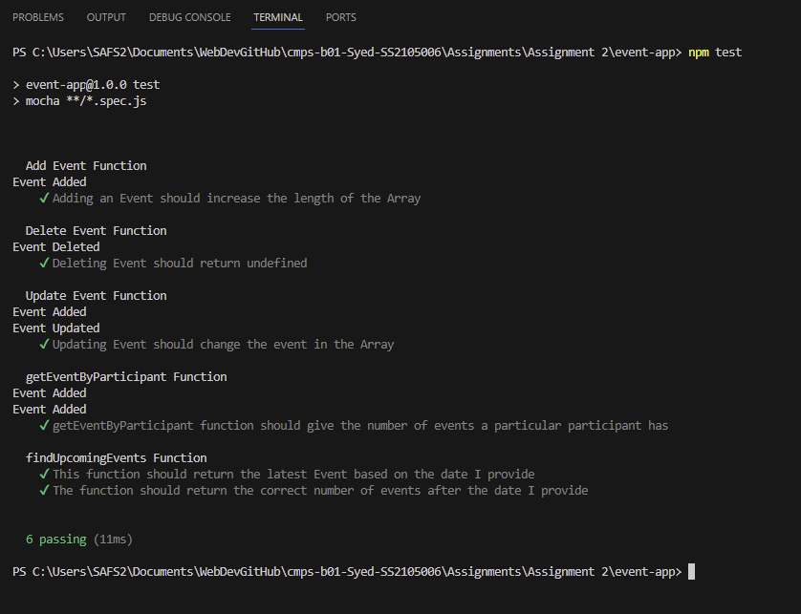

**APP.JS: EVERY FUNCTION IS TESTED HERE:**



